**Why design reactors?**

* Control reaction conversions
* Cannot arbitrarily control reaction mechanisms or rates
* Issues of reactor size, mass transport, thermal control, etc. vs. economics

**Ideal Batch Reactor**

* Constant volume
* Uniform composition, varies with time
* Isothermal

**Steady State Flow Reactors**

Mixed Flow Reactor

* Uniform composition in position
* Composition does not vary with time
* Outlet concentration = reactor concentration
* Constant volume

Plug Flow Reactor

* Composition varies with axial position
* Composition does not vary with time
* Constant volume
* No axial mixing
* Homogeneous radial composition

**Mass Balance**

Accumulation = In - Out + Generation - Consumption

0 = In - Out - Consumption

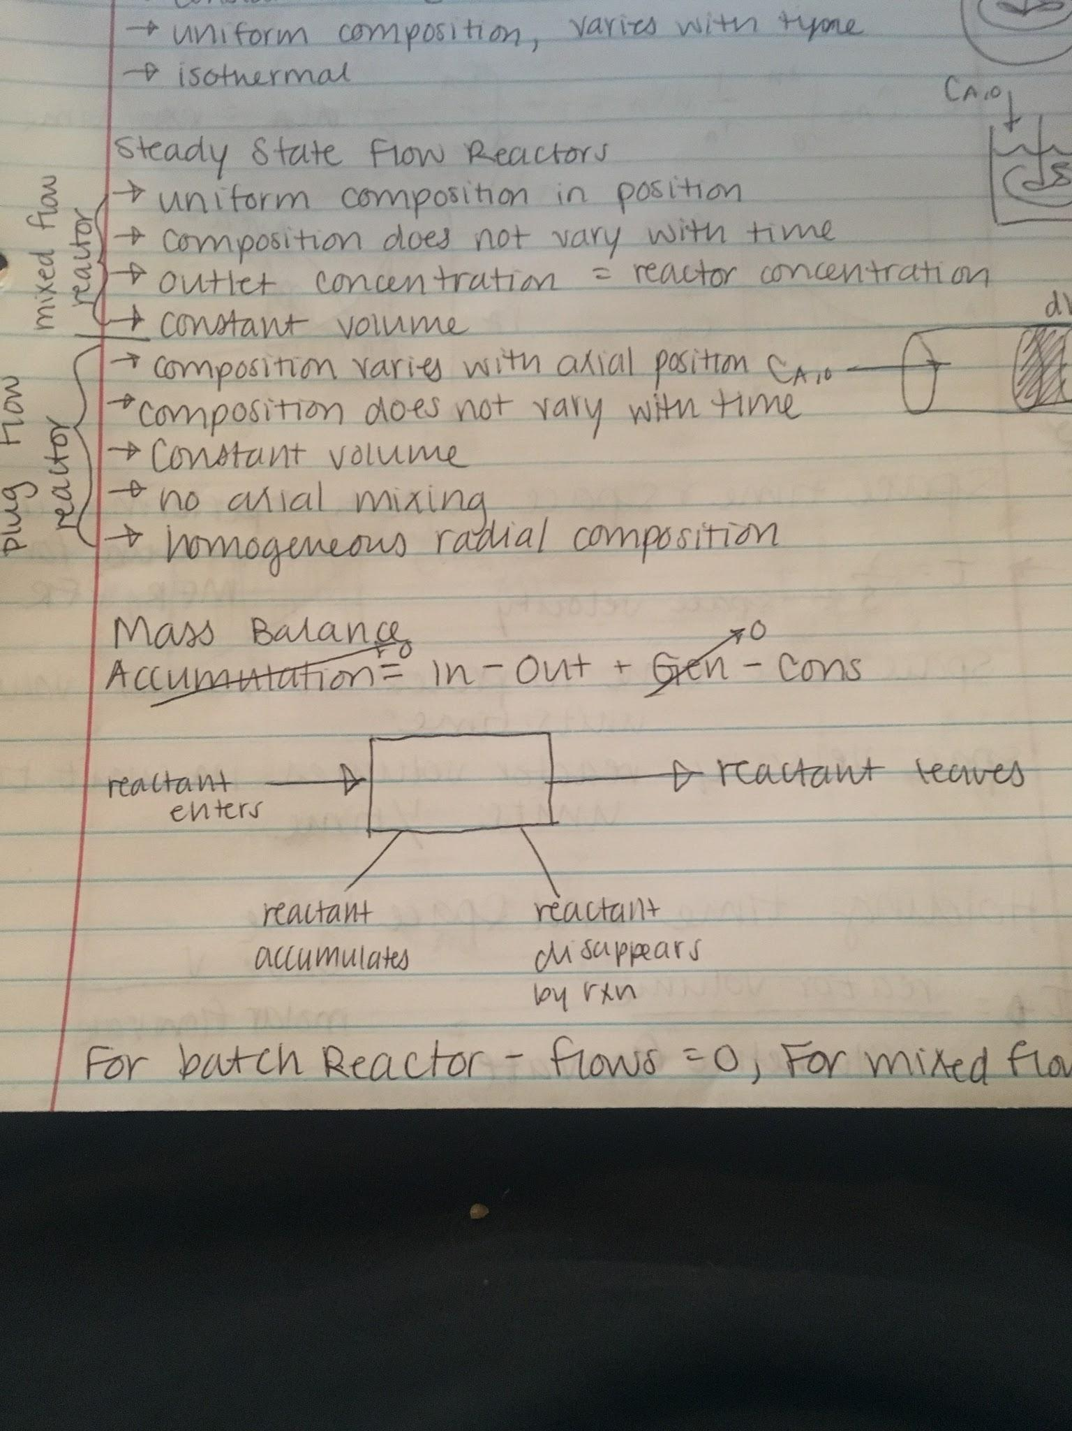

For batch reactor: flows = 0, for mixed flow/plug flow, acceleration = 0

**Ideal Batch Reactor**

Accumulation = In - Out + Generation - Consumption

Accumulation = - Consumption = -NA0 * dXA/dt = -rAV

t = NA0 ∫0XA 1/-rA dXA

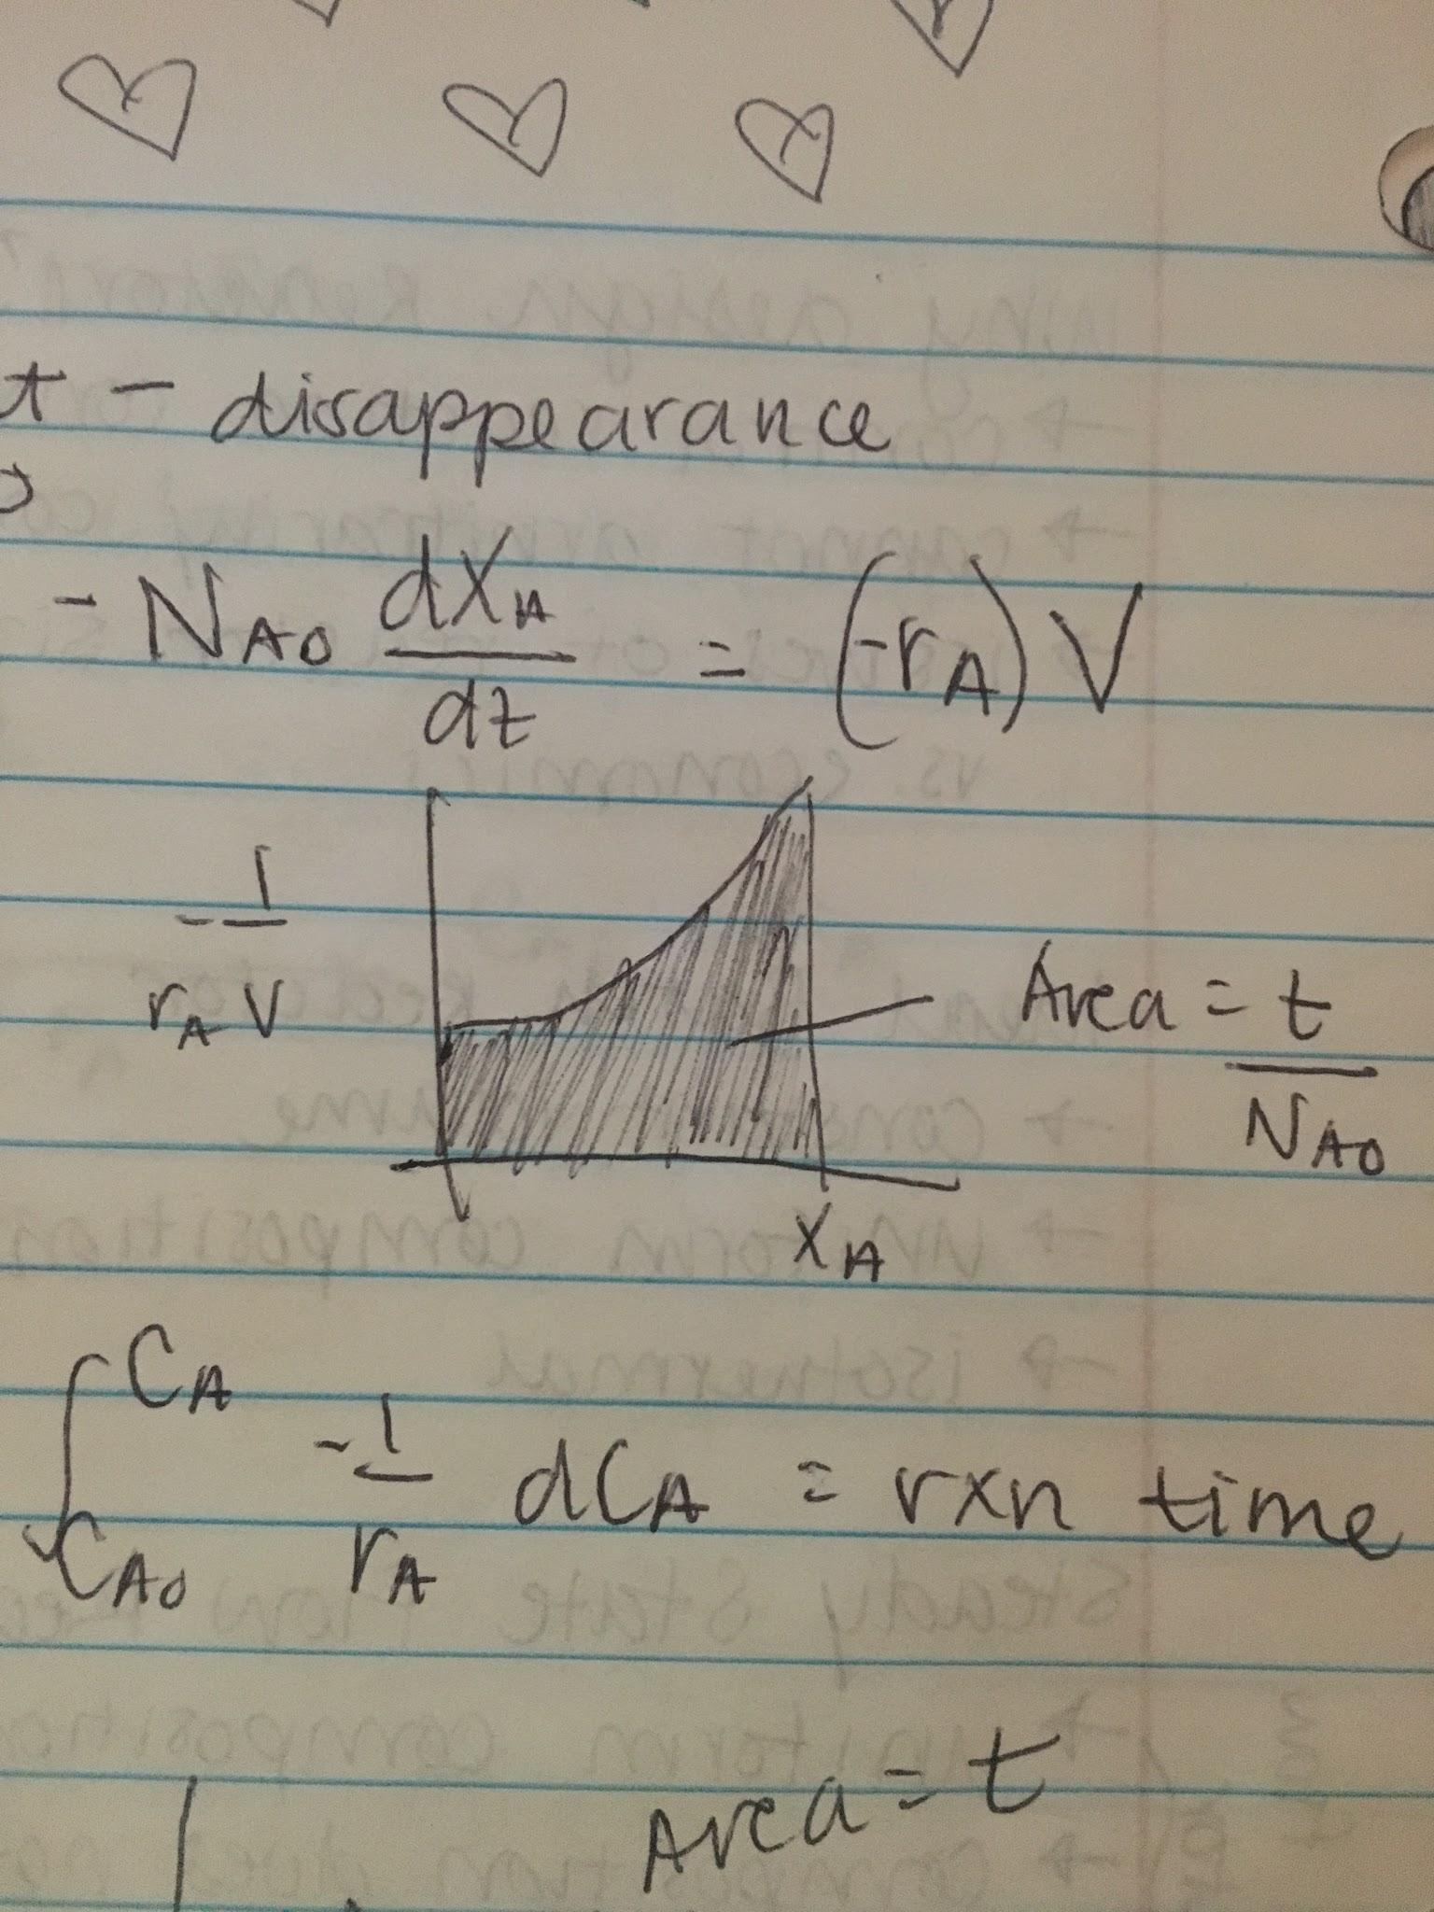

**Constant Volume**

t = CA0 ∫0XA 1/-rA dXA = -∫CA0CA 1/-rA dCA = reaction time

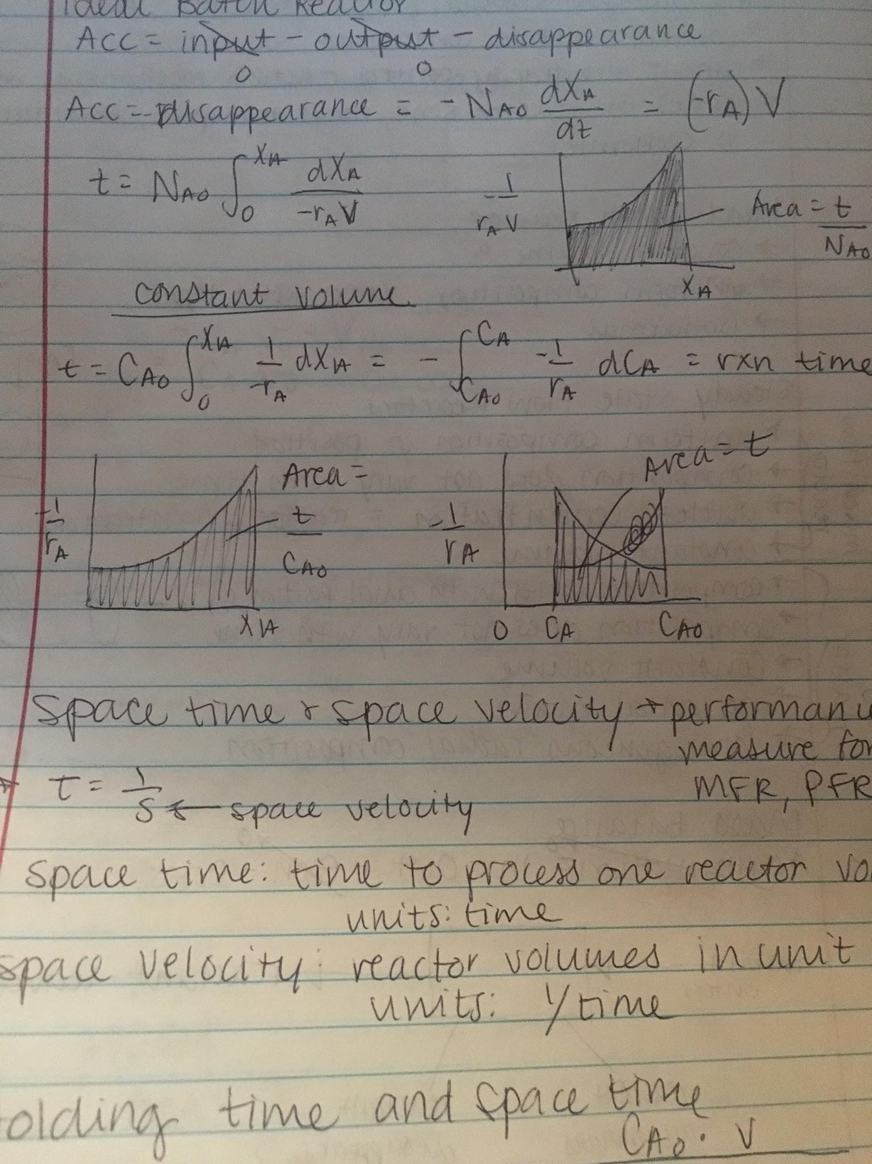

**Space Time and Space Velocity**: performance measure for MFR, PFR

Space time: 𝜏 = 1/s, time to process one reactor volume, units: time

Space velocity: s = 1/𝜏, reactor volumes in unit time, units: time-1

**Holding Time and Space Time**

𝜏 = reactor volume/volumetric flow rate = CA0 * V / molar flow rate

**Ideal Steady State MFR**

* Composition uniform
* Exit conditions = reactor conditions

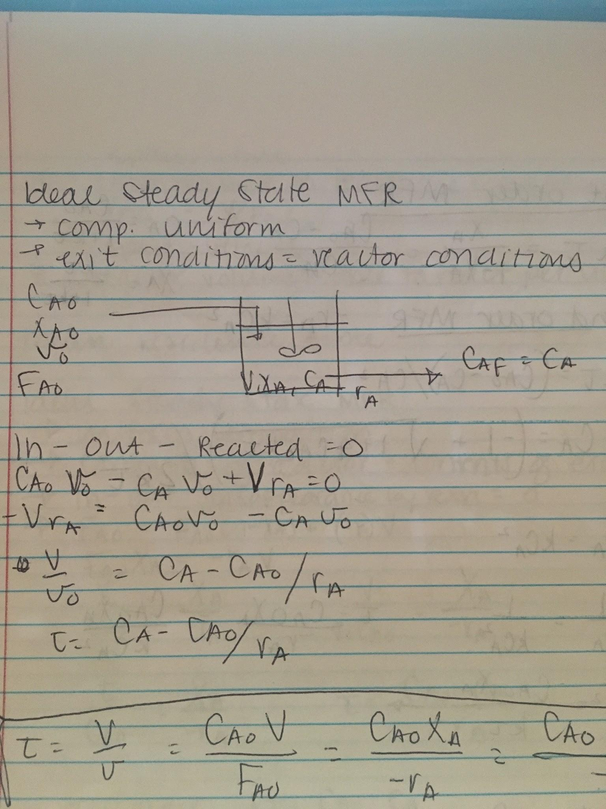

In - Out - Reacted = 0

CA0v0 - CAv0 + VrA = 0

-VrA = CA0v0 - CAv0

V/v0 = CA - CA0/rA

𝜏 = CA-CA0/rA

𝜏 = V/v0 = CA0V/FA0 = CA0XA/-rA = CA0 - CA/-rA

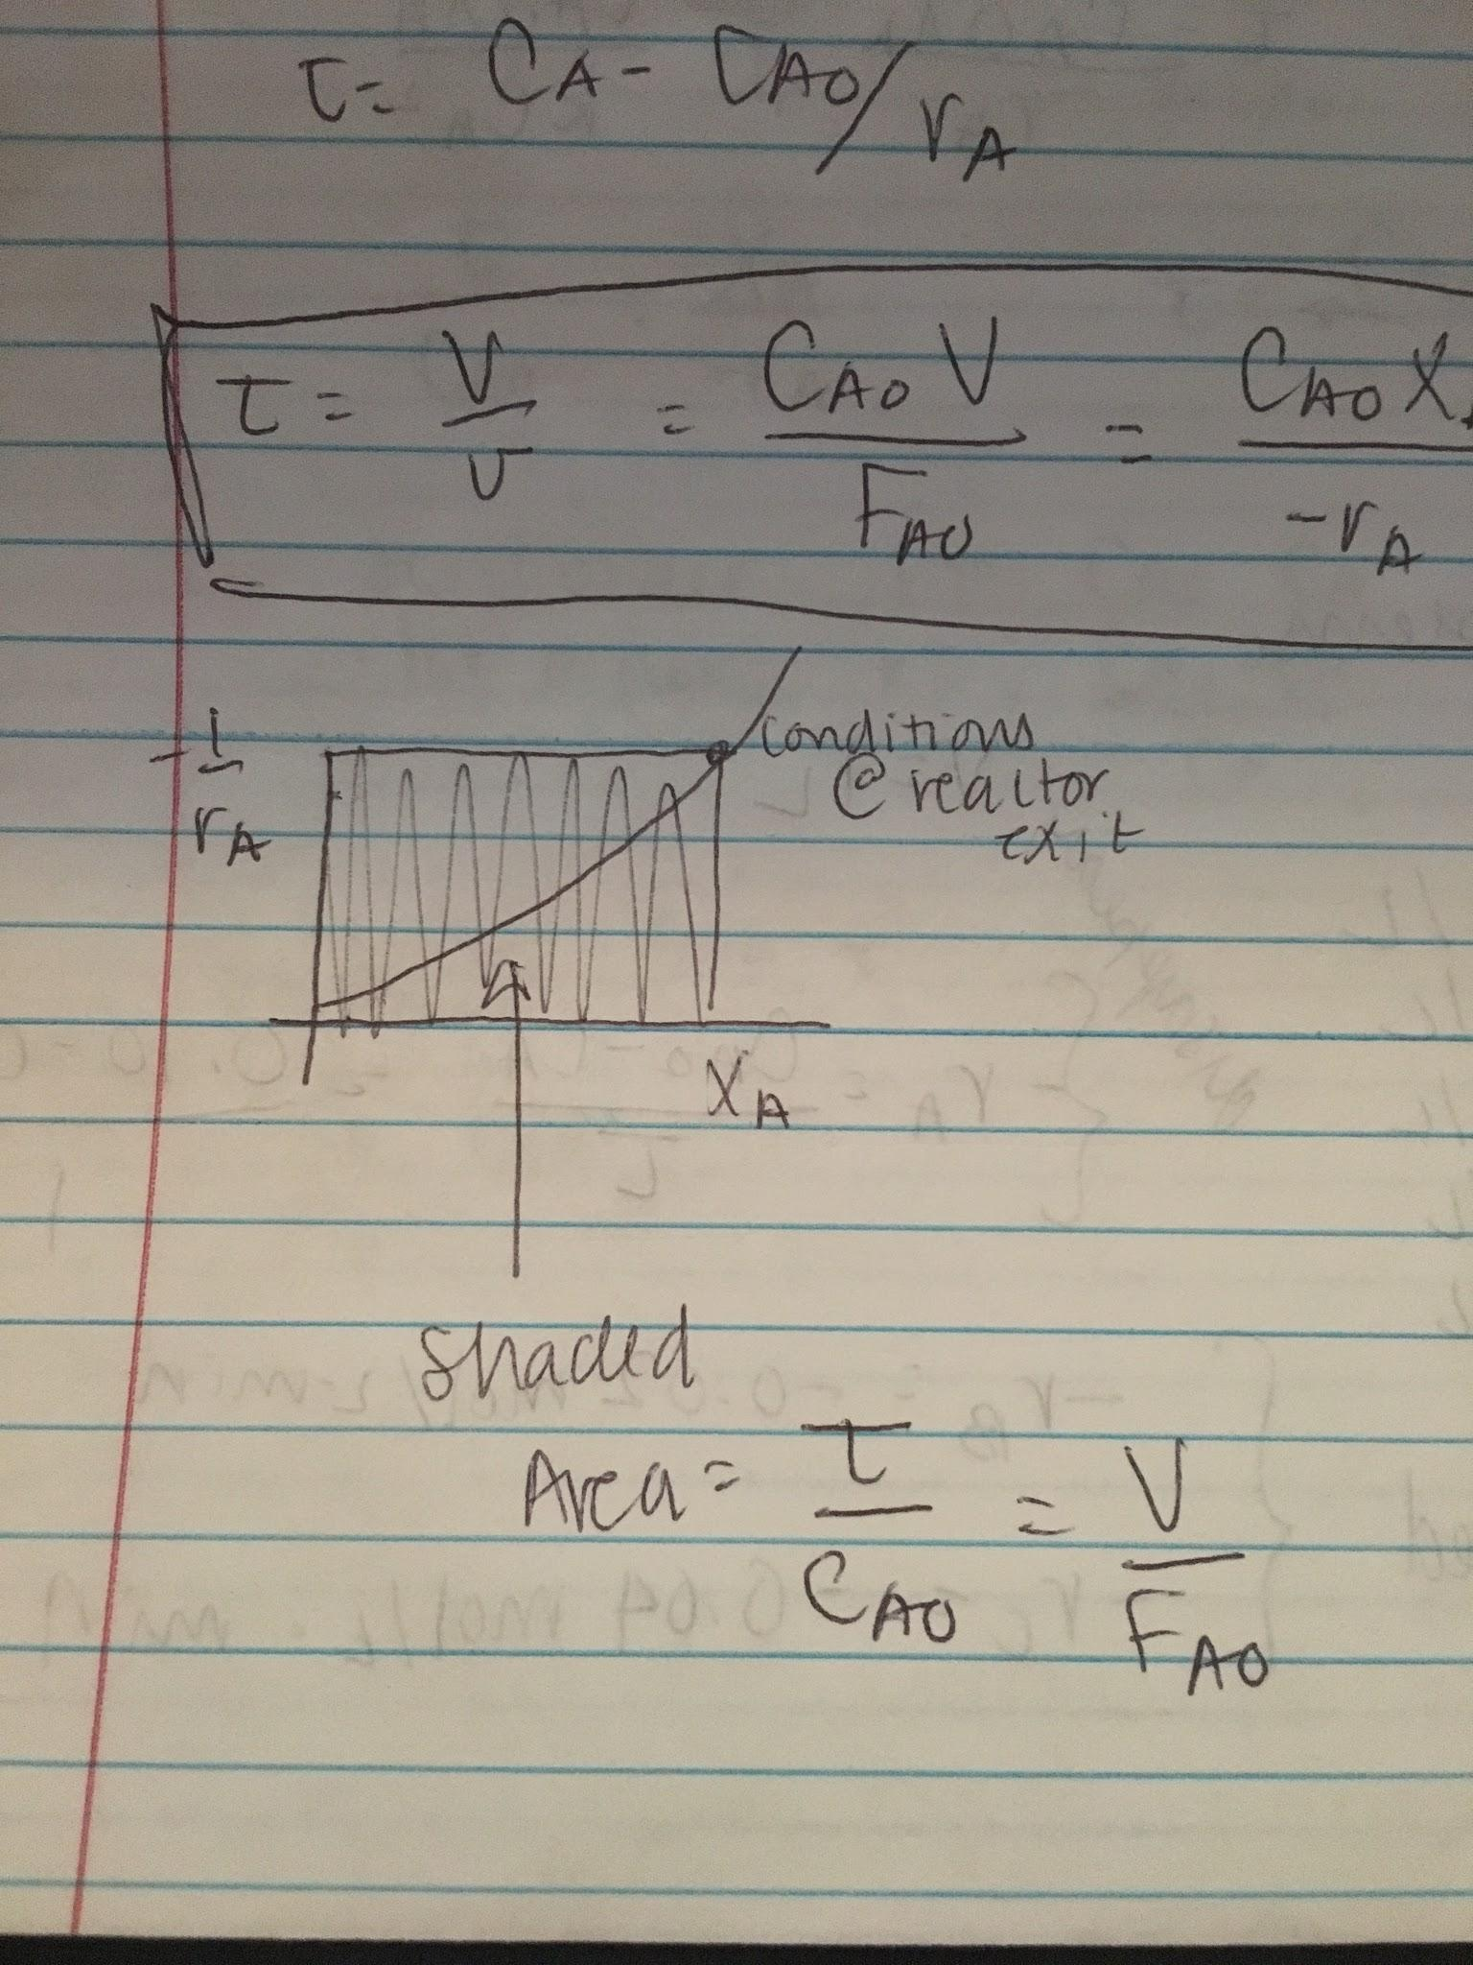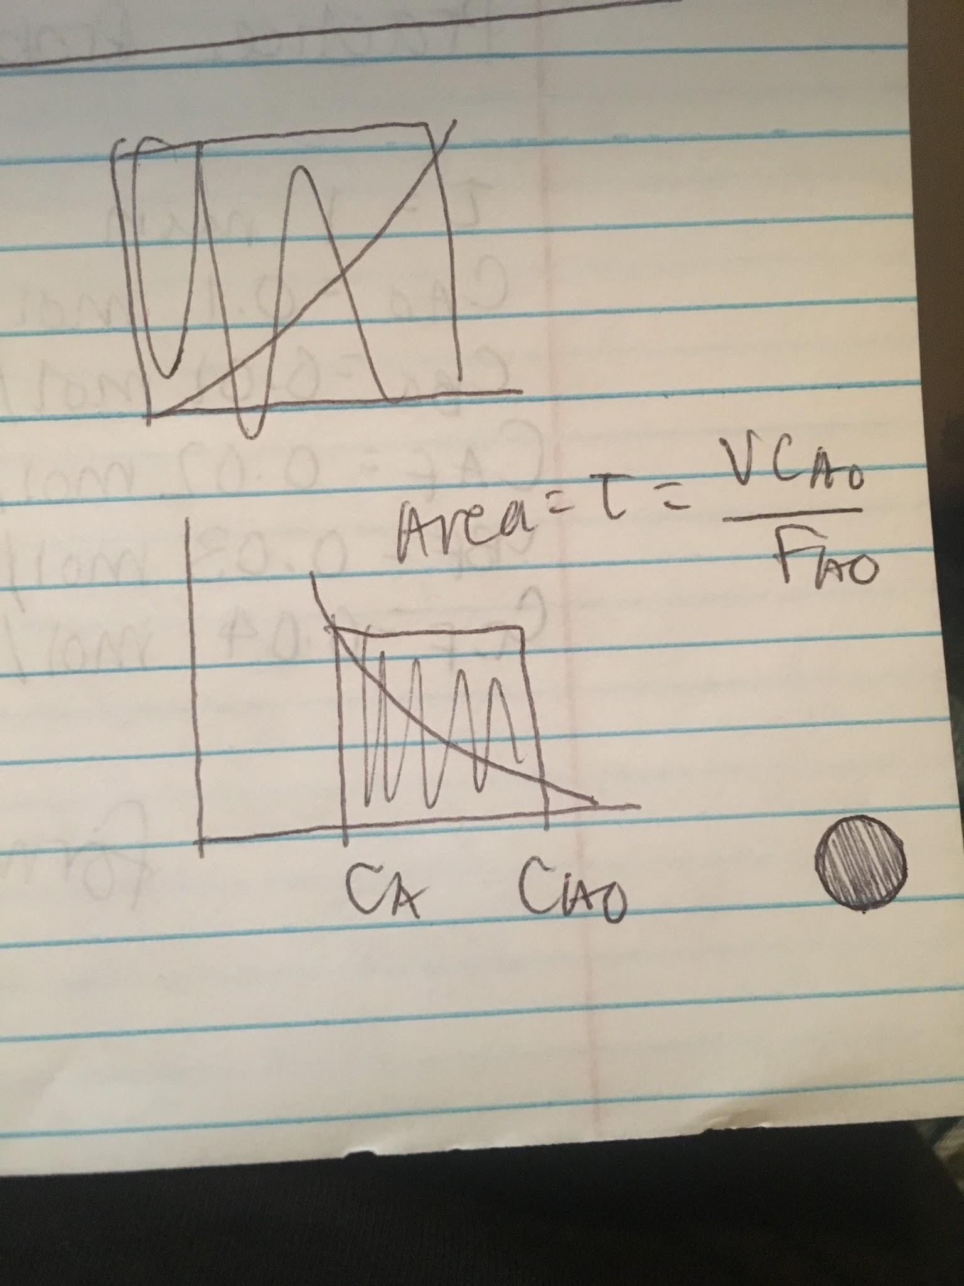

**First Order MFR**

k𝜏 = XA/(1-XA) = CA0 - CA/CA

CA = CA0/(1+k𝜏)

XA = k𝜏/(1+k𝜏)

**Second Order MFR**

k𝜏 = CA0 - CA / CA2

CA = (-1 + [1 + 4CA0k𝜏]1/2)/2k𝜏

-rA = kCA2

-1/rA = 1/kCA2

𝜏 = CA0XA/-rA = CA0XA/kCA2

CA2 = CA0XA/k𝜏

**Practice Problem**

𝜏 = 1 min

CA0 = 0.1 mol/L

CB0 = 0.01 mol/L

CAf = 0.02 mol/L

CBf = 0.03 mol/L

CCf = 0.04 mol/L

V = 1 L

Disappearance: -rA = CA0-CA/𝜏 = 0.10 - 0.02 / 1 = 0.08 mol/L min

Formation: -rB = 0.02 mol/L min; -rC = -0.04 mol/L min